**CRM Application For Management - (Admin)**

**College**: Sri sarathi institute of engineering and technology

**Team member**: Maparthi Jyothsna

(kotaiahjyothsna@gmail.com)

**1.1About the project:**

*A “*CRM Application for Jewel Management - (Admin)*”* aims to achieve several key objectives that ultimately contribute to the growth and efficiency of a jewelry business. The system specifically designed for jewelry business, allowing them To effectively track customer interactions, manage sales leads, and personalize marketing efforts optimize customer relationship and boost sales within the jewelry industry. Capture detailed customer information including demographics, purchase history, preferred jewelry types, special occasions, and contact details,Store and update customer data in real time to maintain accuracy .

*The purpose of a CRM (Customer Relationship Management) system is to help businesses manage and improve their interactions with customers and potential customers. This overarching goal breaks down into several key objectives.* CRM, or Customer Relationship Management, is a multifaceted concept that's essential for modern businesses. It's not just a piece of software it's a strategic approach to how a company interacts with its customers.  The relationship between CRM (Customer Relationship Management) and CLV (Customer Lifetime Value) is very strong. CRM systems provide the tools and data necessary to effectively calculate, track, and ultimately increase CLV.

The Jewel Inventory System is a comprehensive software Solution designed to streamline and manage the inventory and sales processes of a jewellery store or a jewellery manufacturer. The system aims to provide an efficient and user-friendly solution to track and control the inventory of various jewellery items, maintain accurate records, and facilitate seamless sales transactions.

**2.1 OBJECTIVES:**

Creating an object in Salesforce organisation is essential for efficient data management and process automation. By defining custom objects, businesses can structure and store data specific to their needs, enabling streamlined workflows, personalised reporting, and enhanced user experiences. Objects serve as the foundation for organising and leveraging critical information within Salesforce.

**There are TWO main objectives of a CRM**

* Standard Objects
* Custom Objects

Standard Objects: Standard objects are the kind of objects that are provided by salesforce.com such as users, contracts, reports, dashboards, etc.

Custom Objects: Custom objects are those objects that are created by users. They supply information that is unique and essential to their organization. They are the heart of any application and provide a structure for sharing data.

1. Real Time Salesforce Project
2. Data Modelling
3. Creating an Application
4. User Interface Customization
5. Object & Relationship in Salesforce
6. Formula fields and Validation rules.
7. Field Dependencies
8. Record Types
9. Cross object formula fields.
10. Conditional formatting.
11. Flows
12. Email alerts and email templates
13. Reports & Dashboards

**3.1 Salesforce Key Features and Concepts Utilized:**

Salesforce is a cloud-based CRM platform that provides various features and concepts to help businesses manage customer relationships, sales, and operations. Here are some key features and concepts utilized in Salesforce

 Key features of Salesforce CRM include: contact management, lead management, opportunity management, sales forecasting, reporting and dashboards, automation through workflows, collaboration tools, cloud-based access, mobile accessibility, AI integration, campaign management, and a single source of truth for customer data, allowing businesses to track and manage customer interactions across all channels effectively; with core concepts like lead qualification, opportunity stages, and customer lifecycle management central to the platform.

***3.1.1Objects :-***

* Jewel Customer
* Items
* Billing
* Prices
* Customer order

***3.1.2 Tabs:***

* Jewel Customer Tab
* Item Tab .. Etc.

**3.1.3 Lightning App** : -

Jewellery Inventory  System

**3.1.4 *Fields:***

* *Lookup Relationship*
* *Master-Detailed Relationship*
* *Text, Phone, Email Fields in Jewel Customer Object*
* *Number Picklist Fields in Item Object*
* *Currency Fields in Price Object*
* *Formula Field (cross object)in Item Object*
* *Also Created some other Fields.*

3.1.5 **Profiles:**

We Created 2 Profiles:

* Gold Smith profile
* Worker profile

**3.1.6 *Roles*:-**

            Salesforce roles are record-level access controls that define what data a user can see in Salesforce.  roles can be used to determine the visibility access of the user and the data they can access in your Salesforce CRM organization. Added Goldsmith role in CEO Role & Added Worker Role which reports to Goldsmith.

**3.1.7 *Users: -***

              A user in Salesforce is anyone who logs in to the platform, including employees, customers, partners, and automated users.

* Niklaus Mikaelson in Goldsmith Profile
* Kol Mikaelson in Worker Profile
* 2 more Users in Worker Profile

**3.1.8  *Page Layouts: -***

*Page layouts control the layout and organization of buttons, fields, s-controls, Visualforce, custom links, and related lists on object record pages. They also help determine which fields are visible, read only, and required. Use page layouts to customize the content of record pages for your users.*

Created 2 Page layouts in Item object named as: -

* “Page Layout for Gold”
* “Page layout for Silver”

**3.1.9 *Record Type: -***

*Record Types are a way of grouping many records of one type for that object.These can be applied to any standard or custom object, and allow you to have a different page layout, fields, required fields, and picklist values.* Created Record Types in Item Object labeled as Gold & Silver.

**3.2.0 *Permission sets: -***

*A permission set is a collection of settings and permissions that give users access to various tools and functions. Permission sets extend users' function.* We Created New Permission Sets & Labeled it as “Per to Worker “ and in Item Object we enabled Gold & Silver object permission we selected “Read, Edit & Create “.  We added Assignments which we used under Worker Profile users.

***3.*2.1  User Adoption: -**

                     User adoption, or onboarding, is the process of customers or new users getting used to a product or service and then deciding to keep using it because it makes a task or goal. *In Jewlery Inventory System we created Jewel Customers under Jewel Customer tab. We created some Records under “Item, Prices, Customer orders & Billing”.*

**3.2.2 Reports: -**

Reports give you access to your Salesforce data. You can examine your Salesforce data in almost infinite combinations, display it in easy-to-understand formats, and share the resulting insights with others. Before building, reading, and sharing reports, review these reporting basics.

     We created 3 reports:

* Prices Report
* Billings with item and Customer order Report.
* Item with Billings Report

**3.2.3 *Dashboards:***

              We created dashboards under “Item with Billings Report “, “Billings with item and Customer order Report”, “Prices Report”. order Report”, “Prices Report**”.**

***3.2.5Flows:***

Flow is a powerful tool that allows you to automate business processes, collect and update data, and guide users through a series of screens. We selected Record Triggered flow and “Selected *the Object as a “Billing” in the Drop-down list. Selected the Trigger Flow where as “A record is Created or Updated”.  Selected the Optimize the flow for: “Actions and Related Records” .*

***Detailed steps to Solution Design: -***

We created objects:

* Jewel customer
* Item
* Billings
* Prices
* Customer Order

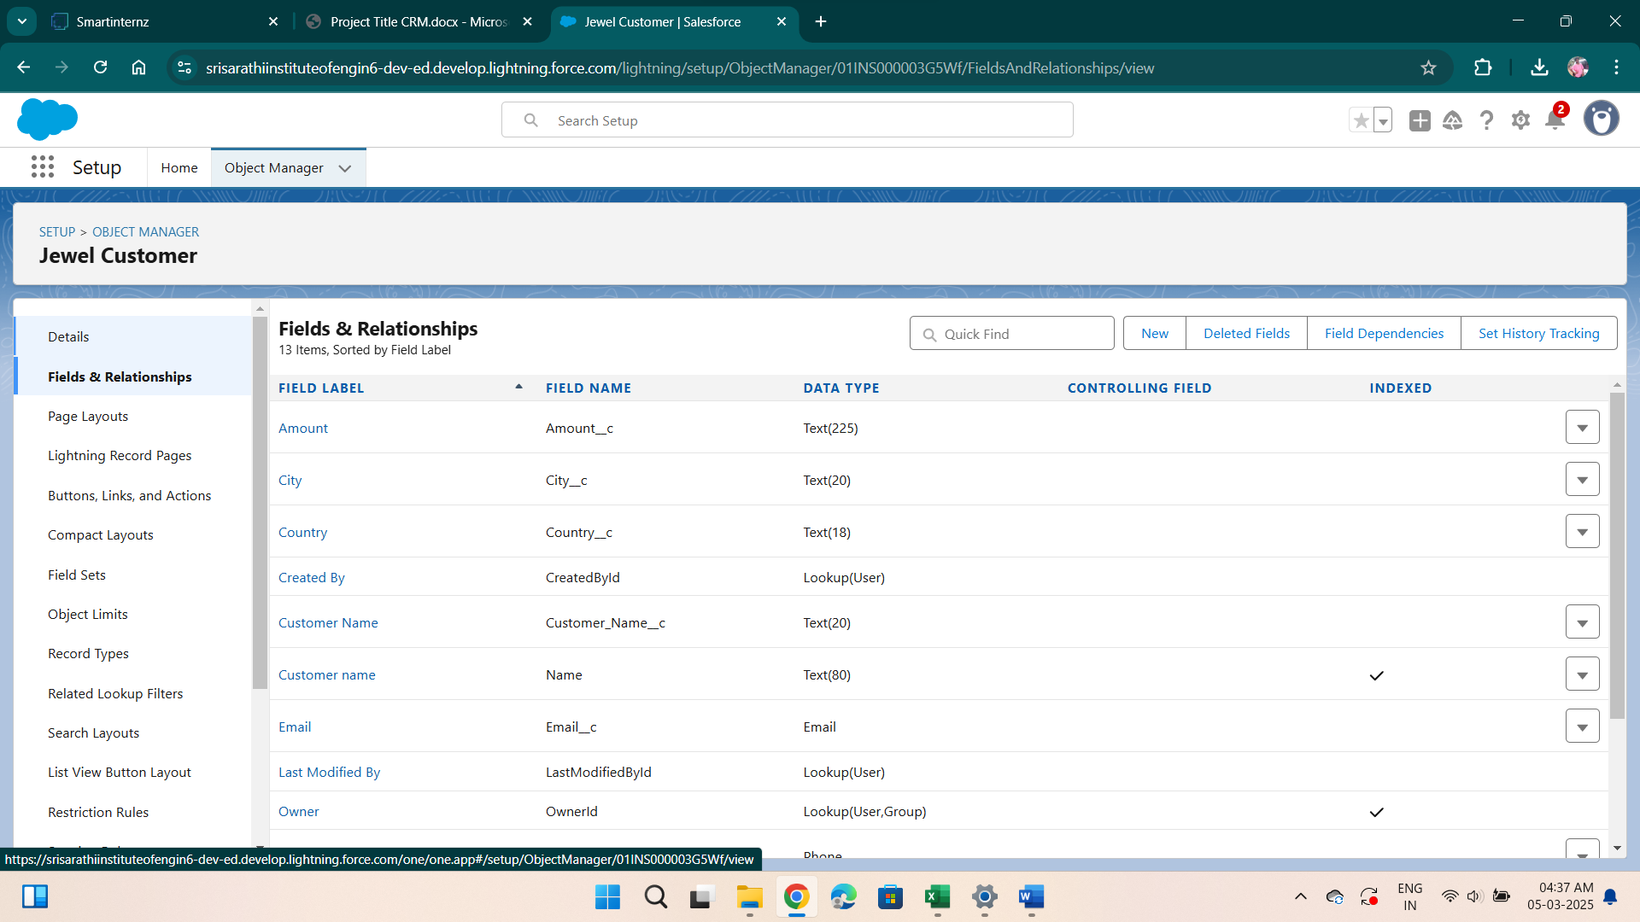

**ITEM:**

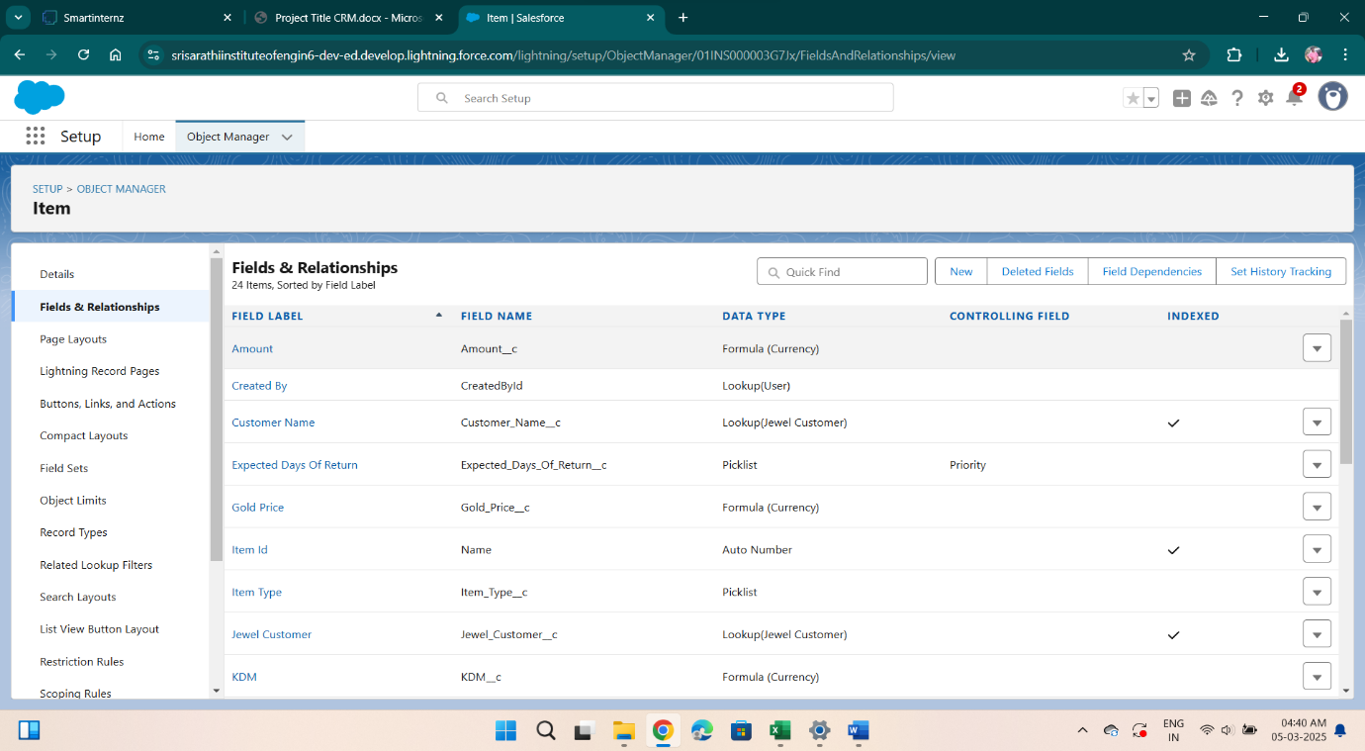

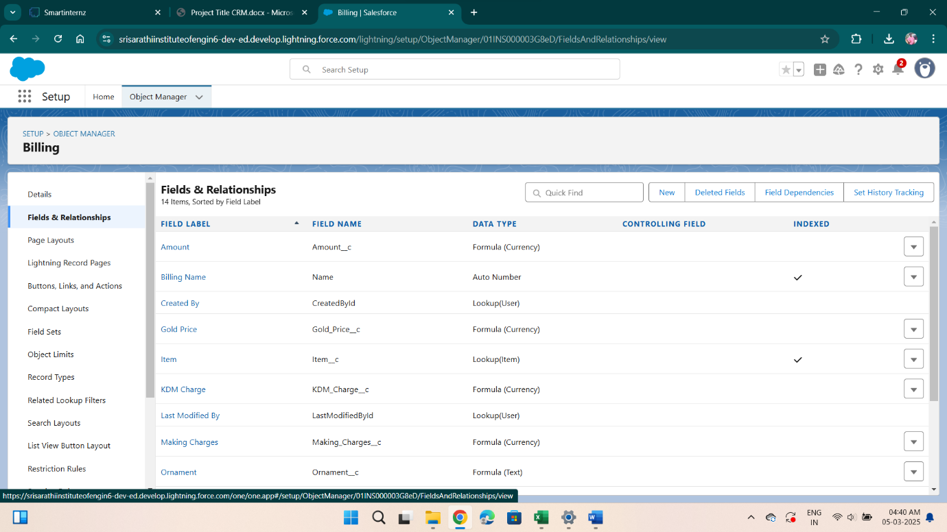***Tabs: -*** 

Types of Tabs:

1. Custom Tabs

Custom object tabs are the user interface for custom applications that you build in salesforce.com. They look and behave like standard salesforce.com tabs such as accounts, contacts, and opportunities.

1. Web Tabs

Web Tabs are custom tabs that display web content or applications embedded in the salesforce.com window. Web tabs make it easier for your users to quickly access content and applications they frequently use without leaving the salesforce.com application.

1. Visualforce Tabs

Visualforce Tabs are custom tabs that display a Visualforce page. Visualforce tabs look and behave like standard salesforce.com tabs such as accounts, contacts, and opportunities.

1. Lightning Component Tabs

Lightning Component tabs allow you to add Lightning components to the navigation menu in Lightning Experience and the mobile app.

1. Lightning Page Tabs

Lightning Page Tabs let you add Lightning Pages to the mobile app navigation menu.

Lightning Page tabs don't work like other custom tabs. Once created, they don't show up on the All Tabs page when you click the Plus icon that appears to the right of your current tabs. Lightning Page tabs also don't show up in the Available Tabs list when you customize the tabs for your apps.

Creating Objects and storing Jewels data is the very first step in the requirements they want. Now to access the stored data by an Owner(Gold Smith) in the organisation Admin needs to create Tabs. By designing a dedicated Tab, businesses can improve user experience, simplify navigation, and provide quick access to critical information, enhancing productivity and ensuring efficient utilisation of Salesforce's capabilities.

*Creating Objects and storing Jewels data is the very first step in the requirements they want. Now to access the stored data by an Owner(Gold Smith) in the organisation Admin needs to create Tabs. By designing a dedicated Tab, businesses can improve user experience, simplify navigation, and provide quick access to critical information, enhancing productivity and ensuring efficient utilisation of Salesforce's capabilities.*

*We created Tabs for Jewel Customer, Prices, Items, Billing & Customer Order.*

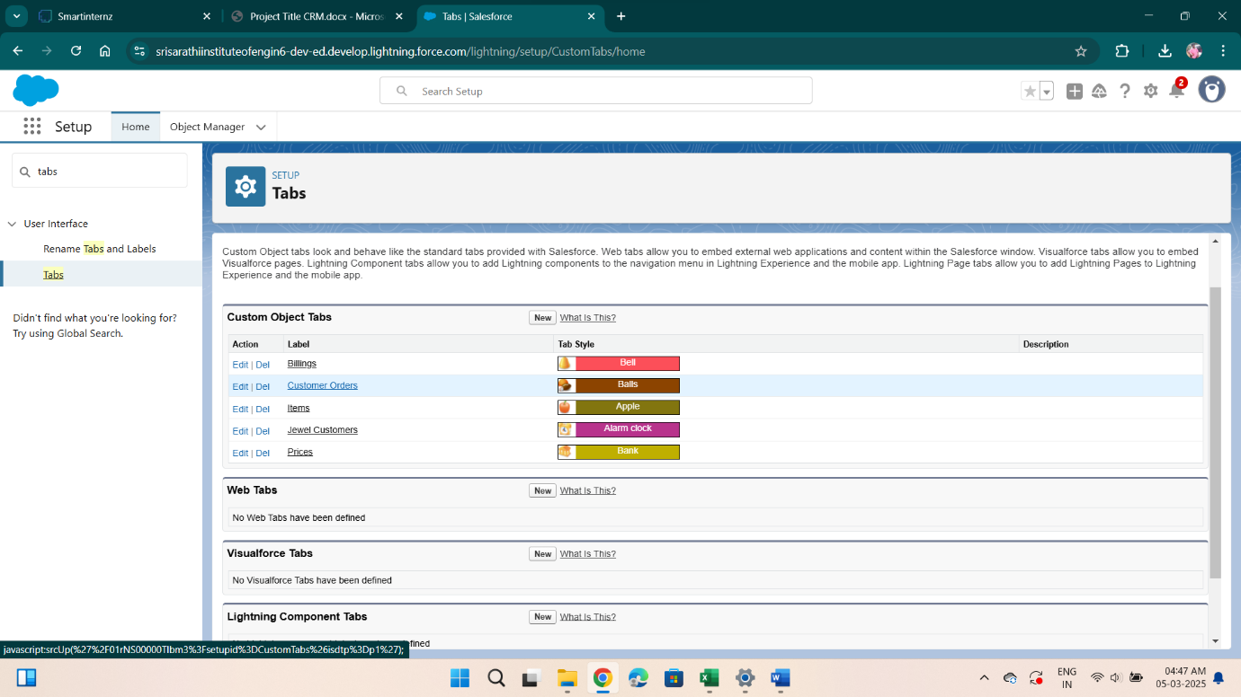

***Lighting App: -***

An app is a collection of items that work together to serve a particular function. In Lightning Experience, Lightning apps gives users access to sets of objects, tabs, and other items all in one convenient bundle in the navigation bar.

Lightning apps let you brand your apps with a custom color and logo. You can even include a utility bar and Lightning page tabs in your Lightning app. Members of your org can work more efficiently by easily switching between apps.

Use Case:

Well done you have reached close to your requirement by creating the objects to store the organization’s data. Making a database for an organization is just not enough to reach out the requirements, the task is how the users at the organization can access the objects you have created for them. As an Admin for the organization it's your duty to make sure every user of the organization is able to access the data modelling structure.

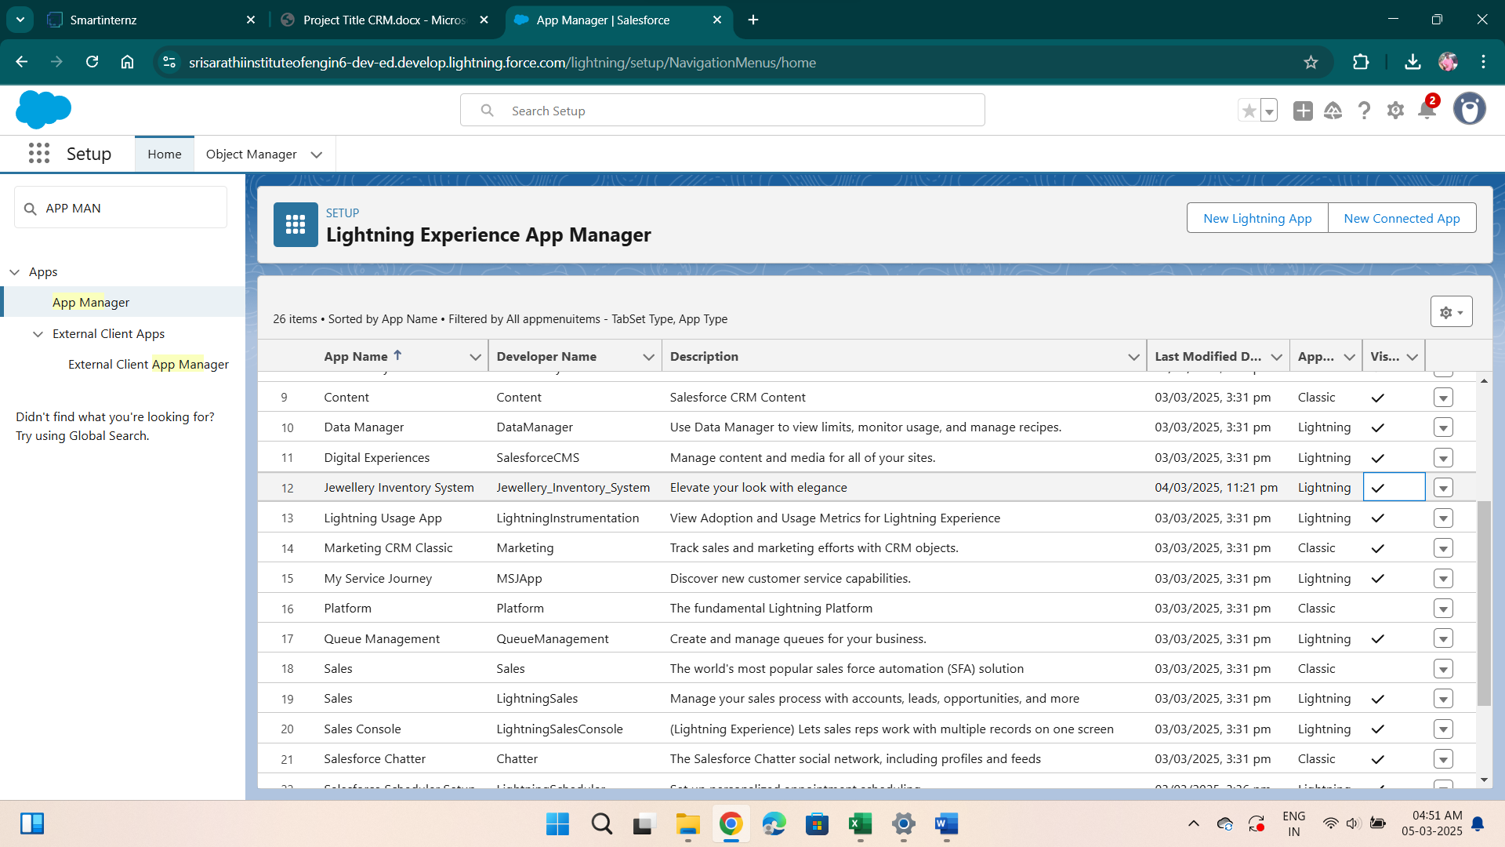

**Schema Builder:**

Creating Remaining Fields in Objects:

Now create the remaining fields using the data types mentioned.

|  |  |  |
| --- | --- | --- |
| s.no | Object name | Fields |
| 1 | Jewel Customer | |  |  | | --- | --- | | Field Name | Data type | | State | Text(20) | | Street | Text(20) | | Country | Text(18) | | Zip/Postal code | Text(6) | |

|  |  |  |  |  |
| --- | --- | --- | --- | --- |
| 2 | Price | |  |  | | --- | --- | | Silver Price | Currency  (Length=8,Decimal=5) | |

|  |  |  |  |  |  |  |  |  |  |  |  |  |  |  |  |  |  |  |  |  |  |  |  |  |  |  |  |  |  |  |  |  |  |  |  |  |  |  |
| --- | --- | --- | --- | --- | --- | --- | --- | --- | --- | --- | --- | --- | --- | --- | --- | --- | --- | --- | --- | --- | --- | --- | --- | --- | --- | --- | --- | --- | --- | --- | --- | --- | --- | --- | --- | --- | --- | --- |
| 3 | Item | |  |  | | --- | --- | | Field Label:Customer Name | Lookup Relationship with Jewel Customer Object | | Ornament | Text(20) | | Weight | Number  (Length=8,Decimal=5) | | Stone Weight | Number  (Length=5,Decimal=5) | | Percentage | Number  (Length=2,Decimal=0) | | Stone/Other Price | Currency  (Length=8,Decimal=2) | | Expected Days Of Return | Picklist   |  | | --- | | 1-3 Days  4-5 Days  6-7 Days  8-10 Days | | | Priority | Picklist   |  | | --- | | Low  Medium  High  Critical | | | Silver Price | Formula     (Return Type:Number)  (Decimal=3)   |  | | --- | | (Prices__r.Silver_price__c  / 1000) | | | Purity Gold Price | Formula     (Return Type:Currency)            (Decimal=2)   |  | | --- | | ((Prices__r.Gold_price__c *  Purity__c ) / 24) / 10 | | | Total Weight | Formula      (Return Type:Number)  (Decimal=3)   |  | | --- | | (Weight__c  -  Stone_weight__c) | | | Amount | Formula  (Return Type:Currency)  (Decimal=3)   |  | | --- | | IF(ISPICKVAL( Item_Type__c ,"Gold"), Total_weight__c  *   Purity_Gold_price__c  , Total_weight__c  *  Silver_price__c ) | | | KDM | Formula  (Return Type:Currency)  (Decimal=0)   |  | | --- | | (Amount__c    *  Percentage__c  ) / 100 | | | Making Charges | Formula  (Return Type:Currency)  (Decimal=0)   |  | | --- | | IF(ISPICKVAL( Item_Type__c ,"Gold"),  Weight__c   *  300 ,  Weight__c  *  10 ) | | |

|  |  |  |  |  |  |
| --- | --- | --- | --- | --- | --- |
| 4 | Customer Order | |  |  |  | | --- | --- | --- | | Order Status | Picklist   |  | | --- | | Started  Not Started  On Hold  Completed  Not Completed | | |

|  |  |  |  |  |  |  |  |  |  |  |  |  |  |  |  |  |  |  |  |  |  |  |  |  |  |  |  |  |  |  |  |
| --- | --- | --- | --- | --- | --- | --- | --- | --- | --- | --- | --- | --- | --- | --- | --- | --- | --- | --- | --- | --- | --- | --- | --- | --- | --- | --- | --- | --- | --- | --- | --- |
| 5 | Billing | |  |  | | --- | --- | | Field Label:Item | Lookup Relationship                with Item Object | | Ornament | Formula      (Return Type:Text)     |  | | --- | | Item__r.Ornament__c | | | Stone weight | Formula      (Return Type:Number)              (Decimal=2)     |  | | --- | | Item__r.Stone_weight__c | | | Weight | Formula         Return Type:Number              (Decimal=2)   |  | | --- | | Item__r.Total_weight__c | | | Amount | Formula      (Return Type:Currency)  (Decimal=2)   |  | | --- | | Item__r.Amount__c | | | Gold/Silver Price | Formula      (Return Type:Currency)  (Decimal=2)   |  | | --- | | IF(ISPICKVAL(  Item__r.Item_Type__c  ,"Gold"),  Item__r.Gold_price__c  ,  Item__r.Silver_price__c  ) | | | KDM Charge | Formula      (Return Type:Currency)  (Decimal=0)   |  | | --- | | Item__r.KDM__c | | | Making Charges | Formula      (Return Type:Currency)  (Decimal=2)   |  | | --- | | Item__r.Making_Charges__c | | | Stones/other price | Formula      (Return Type:Currency)  (Decimal=2)   |  | | --- | | Item__r.Stone_other_price__c | | | Total Amount | Formula      (Return Type:Currency)  (Decimal=0)   |  | | --- | | Amount__c   + KDM_Charge__c  +  Stones_other_price__c  +  Making_Charges__c | | |

We created Schema Builders for Jewel Customer, Price, Item, Customer order & Billing.

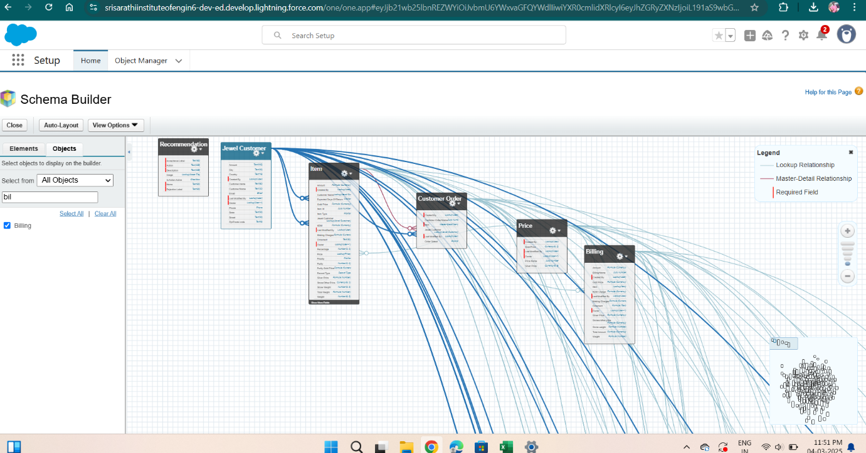

**validation rule:**

Created Validation Rules under Jewel Customer & Item**.**

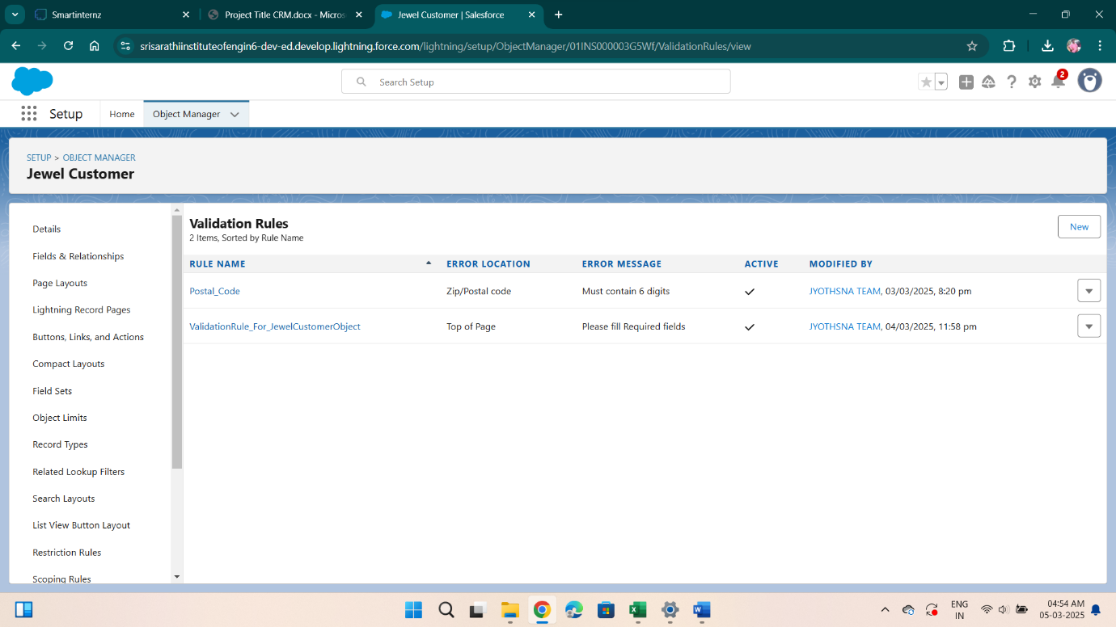

***Profiles: -***

A profile is a group/collection of settings and permissions that define what a user can do in salesforce. Profile controls “Object permissions, Field permissions, User permissions, Tab settings, App settings, Apex class access, Visualforce page access, Page layouts, Record Types, Login hours & Login IP ranges. You can define profiles by the user's job function. For example System Administrator, Developer, Sales Representative.

Types of profiles in salesforce

1. Standard profiles:

By default salesforce provides below standard profiles.

* Contract Manager
* Read Only
* Marketing User
* Solutions Manager
* Standard User
* System Administrator.

We cannot deleted standard ones

Each of these standard ones includes a default set of permissions for all of the standard objects available on the platform.

1. Custom Profiles:

Custom ones defined by us.

They can be deleted if there are no users assigned with that particular one.

        We created 2 Profiles and given name as

* Gold Smith Profile
* Worker Profile

Gold Smith Profile:

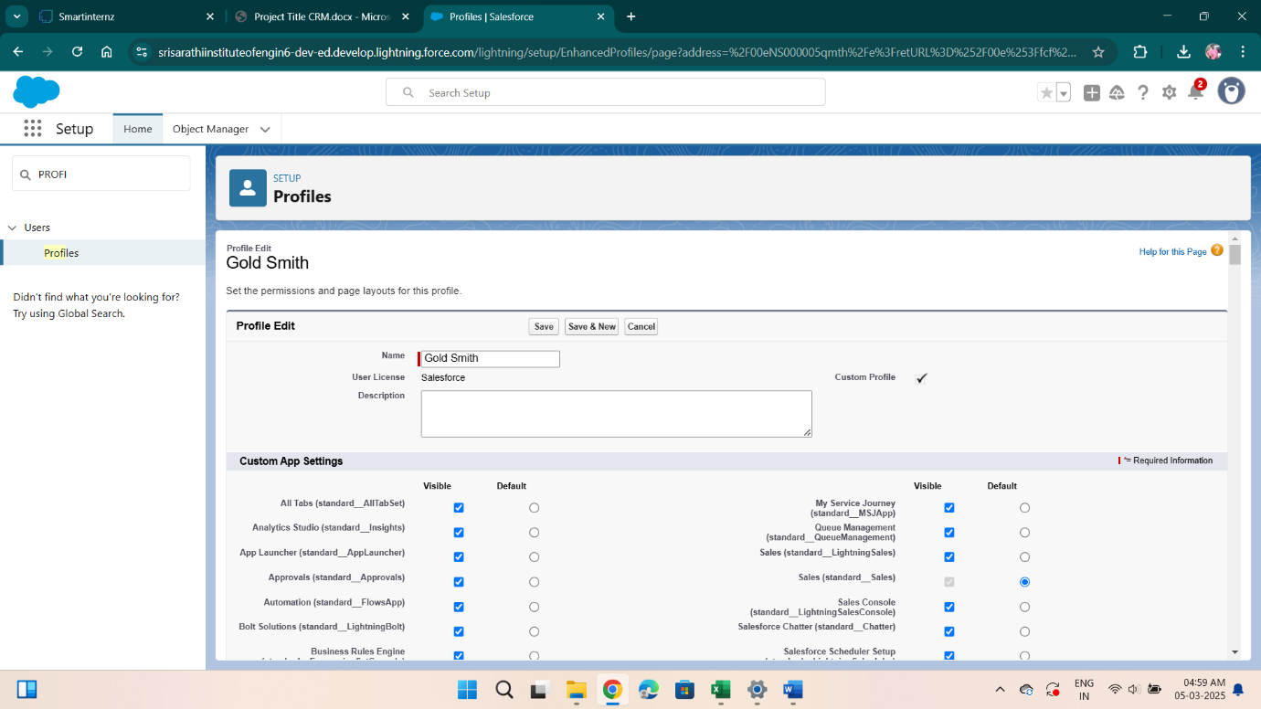

**Worker Profile    :**

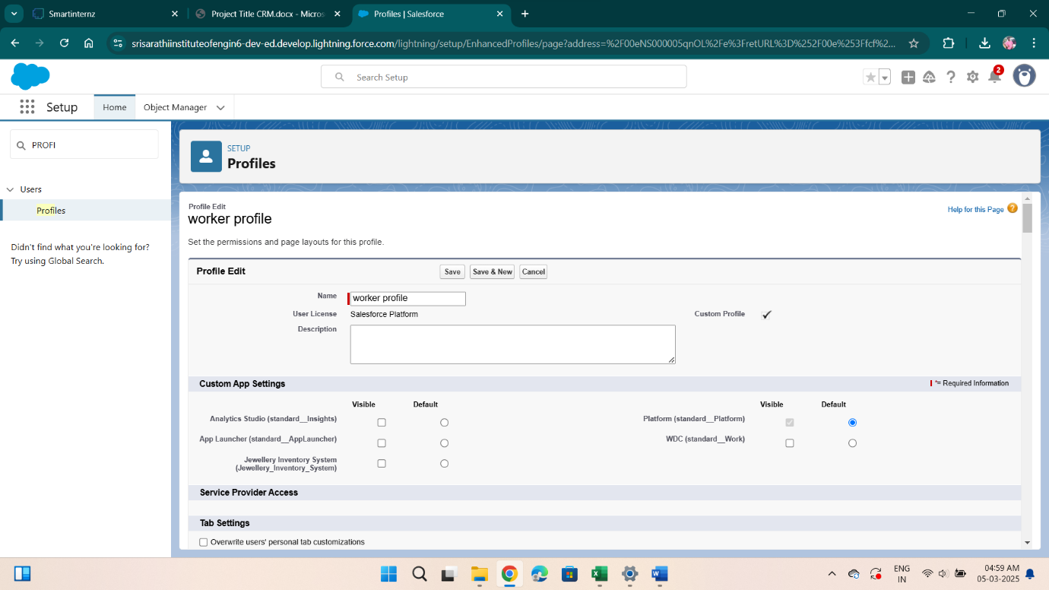

***Roles: -***

A role in Salesforce defines a user's visibility access at the record level. Roles may be used to specify the types of access that people in your Salesforce organisation can have to data. Simply put, it describes what a user could see within the Salesforce organisation.

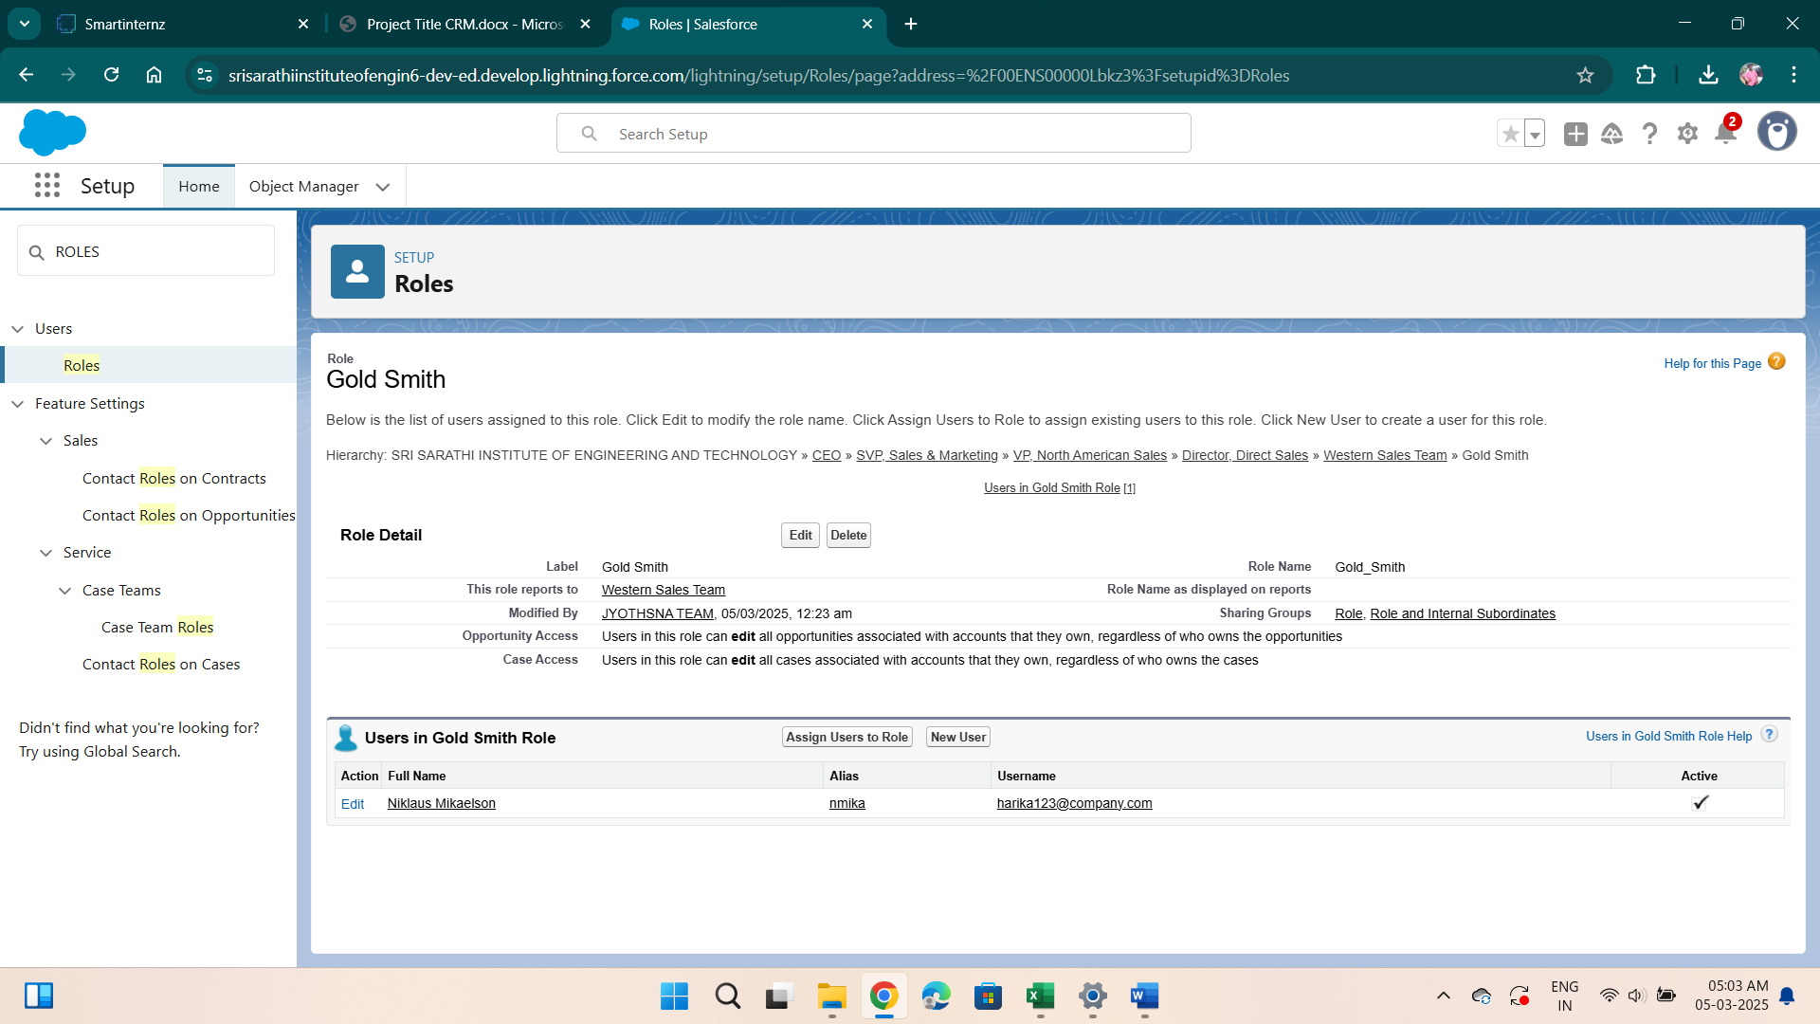

**Users:**

* *Niklaus Mikaelson*
* *Kol Mikaelson*

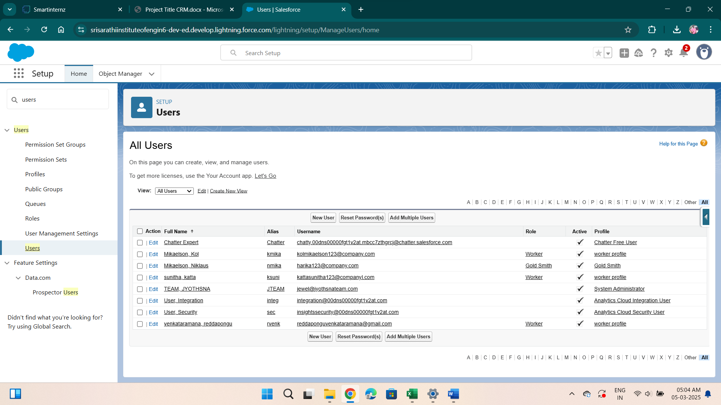

**We created 2-page layouts:**

Page Layouts for Gold & Silver

Page Layouts for Gold :

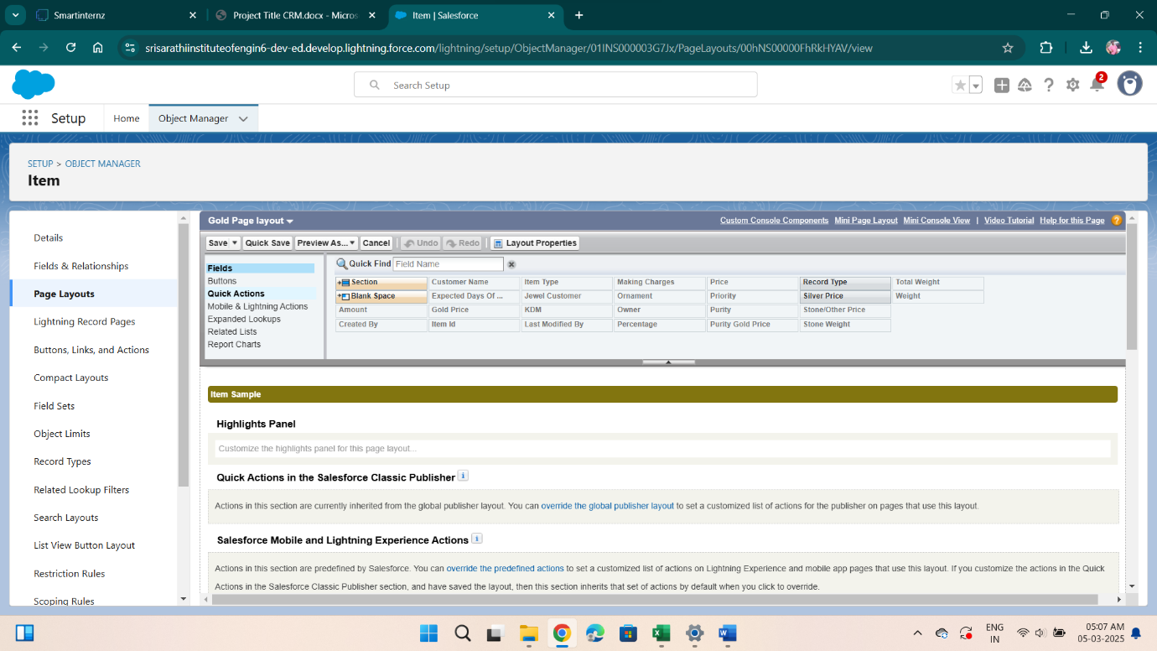

Page Layouts for Silver :

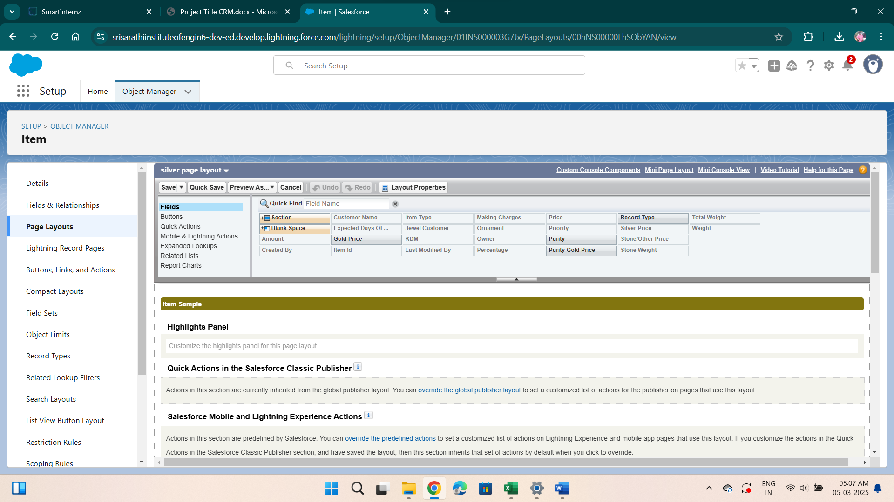

**Record Type:**

Record Types are a way of grouping many records of one type for that object. These can be applied to any standard or custom object, and allow you to have a different page layout, fields, required fields, and picklist values. Record types allow administrators to create a different page layout with custom picklist fields and values for the same business process and various business processes.

We Created Record types in item object and labeled as “Gold" and “Silver”.

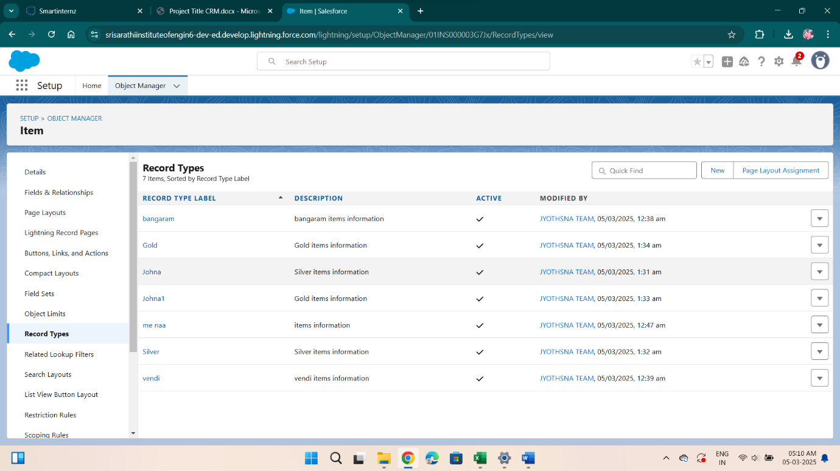

**Permission sets:**

A standard permission set consists of a group of common permissions for a particular feature associated with a permission set licence. Using a standard permission set saves you time and facilitates administration because you don't need to create the custom permission set.

We created permission sets and labeled as “Per to Worker “and selected object permissions for “Read, Edit, Create”.

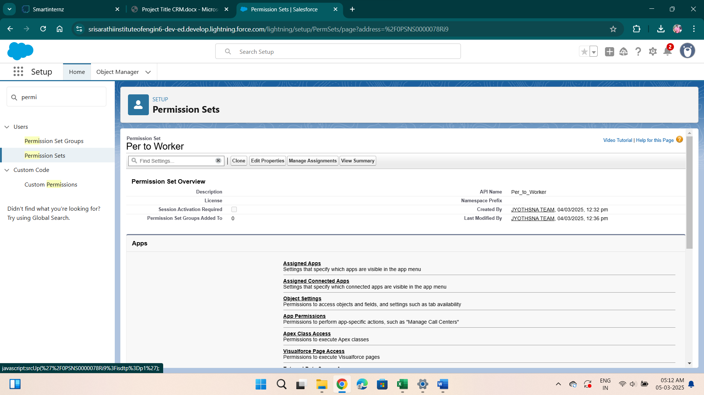

***User Adoption: -***

As a new Administrator, you perform user management tasks like creating and editing users, resetting passwords, granting permissions, configuring data access, and much more**.** We created some jewel customers, items, billings, prices,customer orders in Jewelry Inventory System.

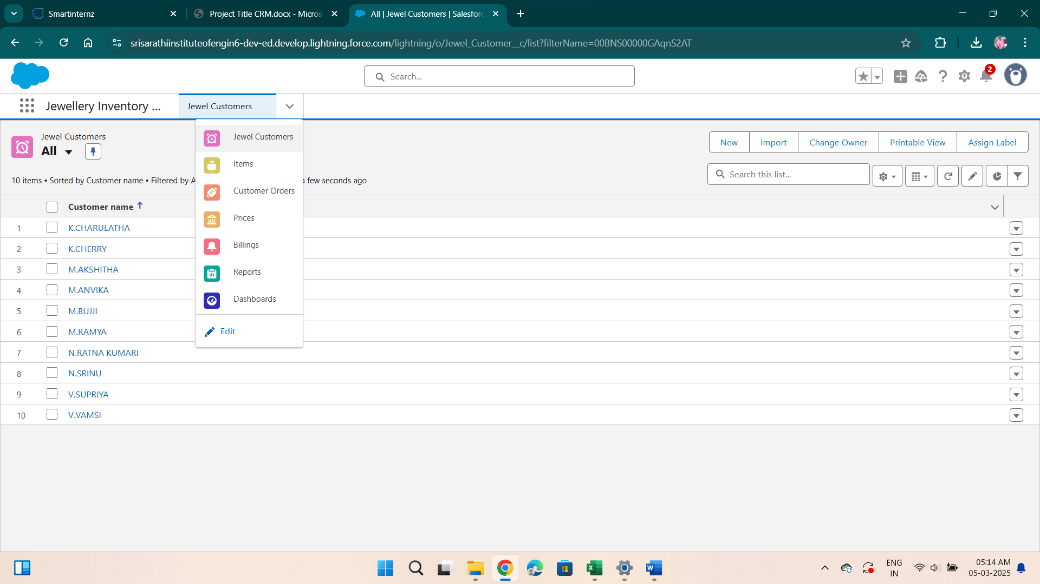

**Reports:**

Reports give you access to your Salesforce data. You can examine your Salesforce data in almost infinite combinations, display it in easy-to-understand formats, and share the resulting insights with others. Before building, reading, and sharing reports, review these reporting basics.

Types of Reports in Salesforce

1. Tabular
2. Summary
3. Matrix
4. Joined Reports

The GoldSmith of an organisation wants to have a brief data on Gold Items,Silver Items,Customer Orders and Billings. So he can have a clear picture of his organisation and be able to make any decisions required based on this data.

**We created 3 Reports:**

* *Prices Report*
* *Item with Billings Report*
* *Billing with Items & Customer order*
* 1. *Prices Report*

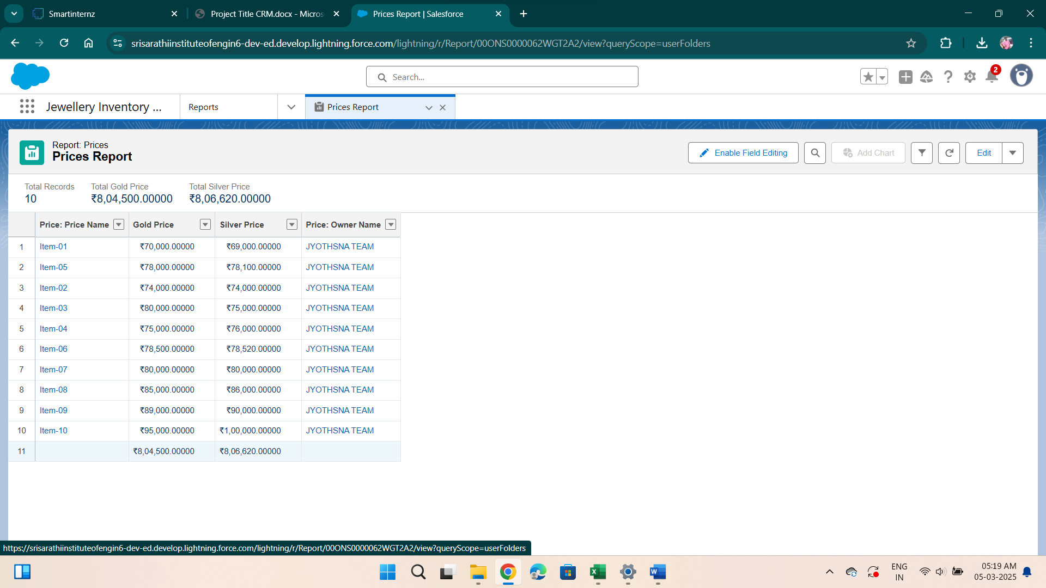

*2.Item with Billings Report* :

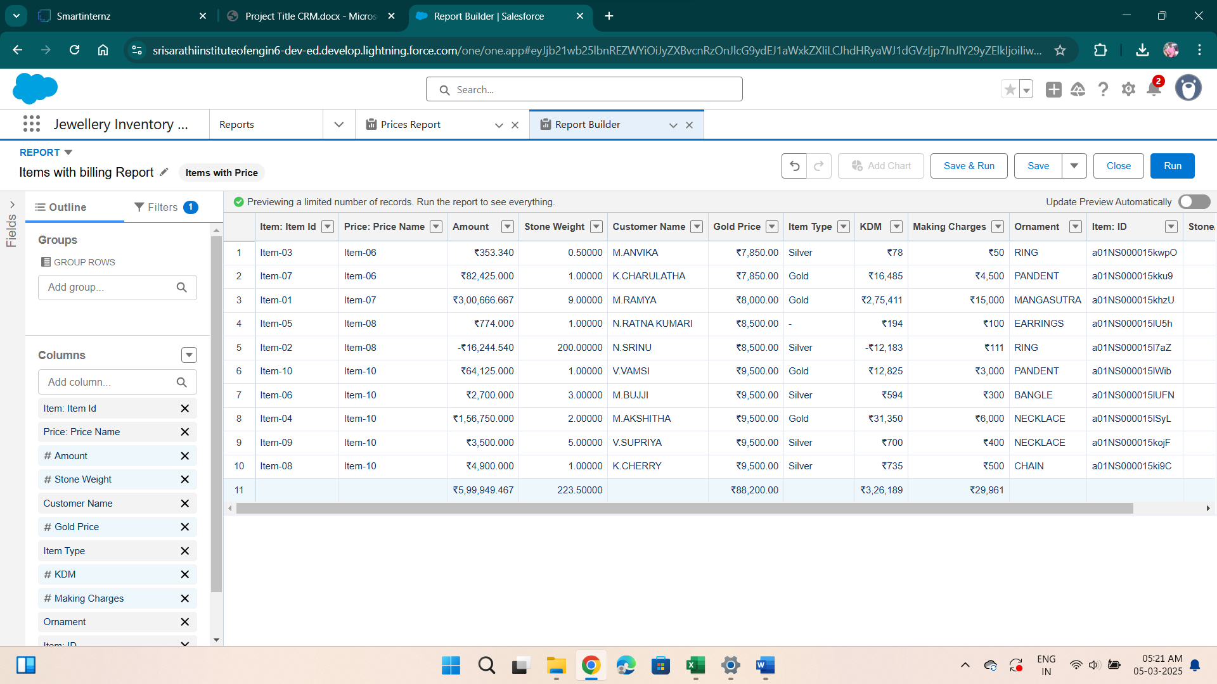

*3.Billing with Items & Customer order* :

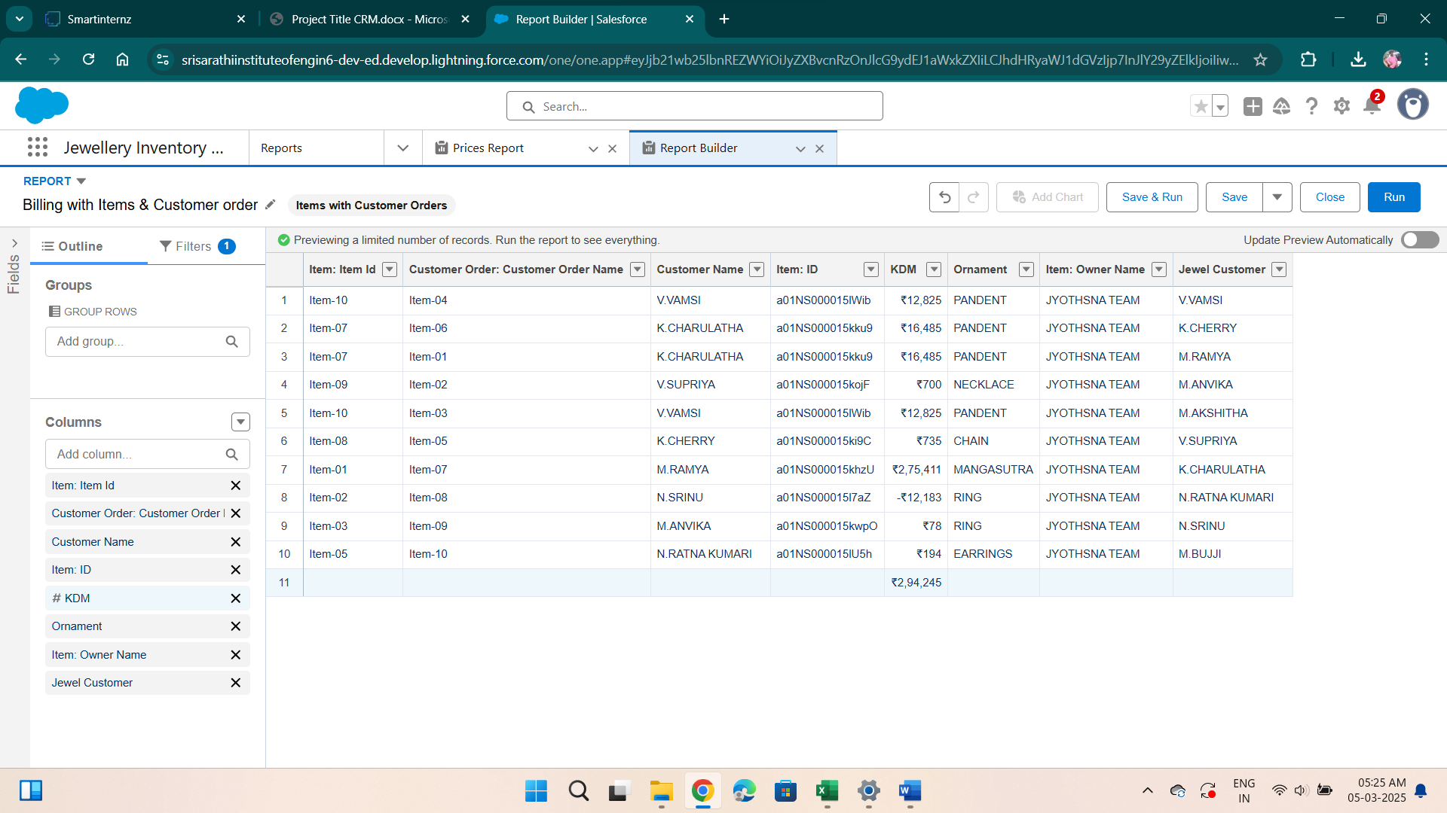

**Conclusion: -**

                                              CRM is a tool that allows businesses to manage relationships with their customers effectively. Customer Relationship management is a business strategy that enables a business organization to maximize revenue, customer satisfaction, and profitability through strategic mobilization, organization, and management of customer’s interests and desires. BWM has traversed numerous business challenges that made it establish a CRM that will foster customer relationship as a baseline for market strengthening and diversification. BMW has diversified its market in various global markets through the initiation of the CRM systems. The system has significantly contributed to the company’s financial, operational, managerial and development initiatives with a robust customer relationship that has fostered great sales of its product. Mercedes Benz operates a similar customer relationship management system just BMW and due to market power, the company has its customerroots to various market bases. Mercedes has majored in customer-dealership business relationships. This has provided the company with strategic mechanization of customer retention, satisfaction and purchase behavior enhancing the company’s profitability through an increased purchase command. The two companies are among the leading CRM implementers in automotive.

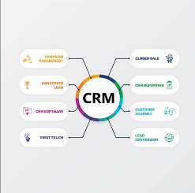

  CRM system is critical for jewelry businesses, allowing them to effectively manage customer relationships by centralizing data, enabling personalized interactions, optimizing sales processes, and gaining valuable insights into customer behavior, ultimately leading to increased sales, improved customer loyalty, and a more streamlined business operation through tailored marketing strategies and exceptional customer service.

                                         A CRM (Customer Relationship Management) system for jewelers is essential for managing customer relationships, enhancing sales, and improving overall business efficiency.

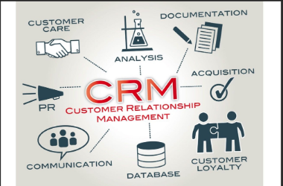

   Jewelry businesses face a multitude of challenges, from fierce competition to changing consumer preferences and limited budgets for marketing and advertising. It can be a tough market to navigate, but the good news is that implementing a customer relationship management (CRM) system can help overcome many of these challenges.

                                   One of the biggest challenges facing jewelry businesses is the need to stay relevant and top of mind with customers. With so many options available, consumers are easily distracted and can quickly forget about your brand. A CRM system can help you stay top of mind by enabling you to communicate with customers on a regular basis and provide personalized recommendations based on their preferences.

             Another challenge is managing inventory and ensuring that you have the right products available at the right time. A CRM system can help you keep track of inventory levels and alert you when products are running low or need to be restocked. This can help you avoid lost sales due to out-of-stock items and ensure that you always have a variety of products available to meet customer demand.

Finally, jewelry businesses face the challenge of attracting new customers and retaining existing ones. A CRM system can help you identify customer segments and target them with personalized marketing messages that resonate with their specific interests and preferences.